***NOTRE DAME UNIVERSITY BANGLADESH***

**Assignment No:01**

***Submitted By:***

**Name**: MD. Saif Hossain

**Department**: CSE

**ID No**: 173120001

**Subject**:CSE 1105

***Submitted To:***

#### A. H. M. Saiful Islam

Associate Professor,Chairman

Department of CSE

NDUB

***Submission date:***

04 /11 /2017

**Program from softcopy: c-4**

**Problems :**

1. **Use of getchar function**
2. **Program to test the char type**
3. **Reading and writing of alphabets in reverse case**
4. **Formatted output of integers**

**No:1 || Program:A program about using getchar function**

**Source code:**

main()

{

char answer;

printf("Would you like to know my name???\n\n");

printf("Type 'Y' for Yes and 'N' for No : ");

answer=getchar(); //reading a character

if(answer == 'y'|| answer == 'Y')

printf("\n\nMy name is Busy BEE\n");

else

printf("\n\nYou are good for nothing\n");

}

**Sample input :**

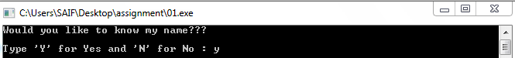

**Sample output:**

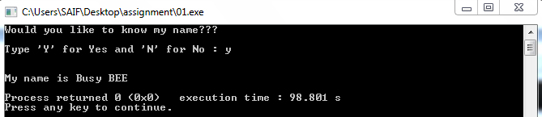

**No:2 || Program:A program about testing character type**

**Source code:**

**main()**

**{**

**char X;**

**printf("Press any Key :");**

**X=getchar();**

**if(isalpha(X)>0)**

**printf("\nThe character is a lattar.\n");**

**else**

**if(isdigit(X)>0)**

**printf("\nThe character is a digit.\n");**

**else**

**printf("\nThe character is not alphanumeric.\n");**

**}**

**Sample input**:



**Sample Output :**

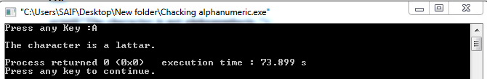

**No:3 || Program:A program Reading and writing of alphabets in reverse case**

**Source code:**

**main()**

**{**

**char alphabet;**

**printf("Enter an alphabet");**

**putchar('\n'); //move to next line**

**alphabet=getchar();**

**if(islower(alphabet))**

**putchar(toupper(alphabet));**

**else**

**putchar(tolower(alphabet));**

**}**

**Sample input:**



**Sample output:**

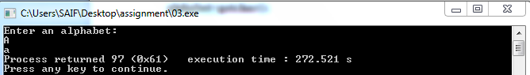

**No:4 || Program: A program Formatted output of integers**

**Source code:**

**main()**

**{**

**int m=12345;**

**long n=987654;**

**printf("%d\n",m);**

**printf("%10d\n",m);**

**printf("%010d\n",m);**

**printf("%-10d\n",m);**

**printf("%10ld\n",n);**

**printf("%10ld\n",-n);**

**}**

**Sample output:**

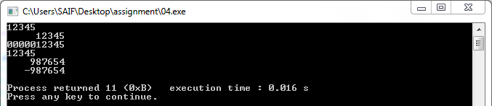

**Program from softcopy: c-5**

1. **Illustration of simple (if) statement**
2. **Use of (if) for counting**
3. **Use of (if-else) to find the larger one**
4. **Selecting the largest of three numbers(if-else)**

**No:1 || Program: A program about illustration of simple (if) statement**

**Source code:**

**main( )**

**{**

**int a,b,c,d;**

**float ratio;**

**printf("enter four integer values\n");**

**scanf("%d %d %d %d",&a,&b,&c,&d);**

**if(c-d !=0)**

**{**

**ratio=(float)(a+b)/(float)(c-d);**

**printf("ratio=%f\n",ratio);**

**}**

**}**

**Sample Input :**



**Sample output:**

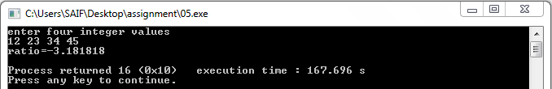

**No :2 || program :A program about Using of (if) for counting**

**Source code**:

//use of if for counting...

main()

{

int count, i;

float weight, height;

count = 0;

printf("Enter weight and height for 10 boys\n");

for (i =1; i <= 10; i++)

{

scanf("%f %f", &weight, &height);

if (weight < 50 && height > 170)

count = count + 1;

}

printf("Number of boys with weight < 50 kgs\n");

printf("and height > 170 cm = %d\n", count);

}

**Sample Input :**

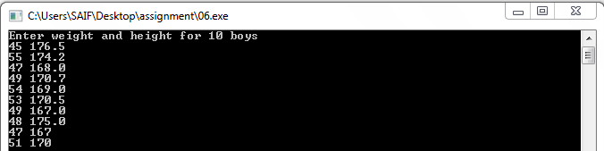

**Sample output:**

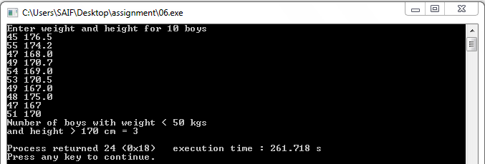

**No:3 || Program**: **A program about Using of (if-else) to find the larger one**

**Source code:**

//find the larger one...

main()

{

int val1;

int val2;

int larger;

printf("Enter two integers:");

scanf("%d %d" ,&val1,& val2);

if(val1>val2)

larger=val1;

else

larger=val2;

printf("larger of inputs is:%d\n",larger);

}

**Sample input**:



**Sample output**:

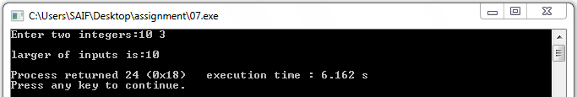

**No:4 || Program**: **A program about selecting the largest of three numbers(if-else )**

**Source code**:

//selecting the largest of three numbers...

main()

{

float A,B,C;

printf("enter three values:\n");

scanf("%f %f %f",&A,&B,&C);

printf("\nLargest value is :");

if(A>B)

{

if(A>C)

printf("%f\n",A);

else

printf("%f\n",C);

}

else

{

if(C>B)

printf("%f\n",C);

else

printf("%f\n",B);

}

}

**Sample input**:



**Sample output**:

